

**International School**

**Capstone Project 2**

CMU-SE 451

**Interface Design Document**

**Version 2.0**

**Date: 06/05/2021**

**ViVu - The smart travel system supports with chatbot and short video social network**

**Submitted by**

**Sang, Nguyen Thanh**

**Thuyen, Pham Van**

**Tuan, Doan Kim**

**Loc, Phung Hoang Phu**

**Approved by Nguyen Duc Man**

**Proposal Review Panel Representative:**

Name Signature Date

**Capstone Project 1- Mentor:**

Name Signature Date

**PROJECT INFORMATION**

|  |  |  |  |
| --- | --- | --- | --- |
| **Project acronym** | ViVu | | |
| **Project Title** | The Smart Travel System Supports With Chat Bot And Short Video Social Network. | | |
| **Start Date** | 24 Aug 2020 | **End Date** | 6 Jun 2021 |
| **Lead Institution** | International School, Duy Tan University | | |
| **Project Mentor** | Man, Nguyen Duc, M.Sc. | | |
| **Scrum master / Project Leader & contact details** | Sang, Nguyen Thanh  Email: thanhsang3111999.ntb@gmail.com  Tel: 0344684069  ID: 23211212363 | | |
| **Partner Organization** |  | | |
| **Project Web URL** |  | | |
| **Team members** | Name | Email | Tel |
| 2321121321 | Tuan, Doan Kim | doantuan21101999@gmail.com | 0913622928 |
| 2321124963 | Loc, Phung Hoang Phu | phunghoangphuloc@gmail.com | 0912698173 |
| 2321125061 | Thuyen, Pham Van | phamvanthuyen2802@gmail.com | 0795697332 |

REVISION HISTORY

|  |  |  |  |  |
| --- | --- | --- | --- | --- |
| **Version** | **Date** | **Comments** | **Author** | **Approval** |
| 1.0 | 10/09/2020 | Initial Release | Tuan |  |
| 1.1 | 23/09/2020 | Add web design | Tuan |  |
| 2.0 | 06/05/2021 | Update Version 2 | Tuan |  |

# Introduction

## Purpose

* This document serves the purpose of specifying application’s UI design

## Scope

* Create complete interfaces, and describe them clearly.
* Overview of the stages and modules of the system

# Describe User Interface Application in Detail

## UI-Tourist

### UI-01: Home

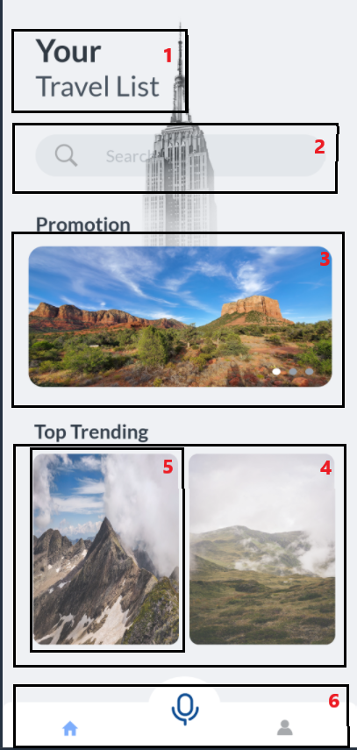

|  |  |  |  |  |
| --- | --- | --- | --- | --- |
| **ID** | **Condition** | **Control Type** | **Target** | **Notes** |
| 1 | Nothing | Picture | Logo of app |  |
| 2 | Click | Text box | enter the name of the tour you want to search |  |
| 3 | Click | Picture | View promotion |  |
| 4 | Scroll | List | List of 10 hottest tours |  |
| 5 | Click | Picture | Photos, tour basic information include: name, price, rate, click on will go to respective details page of the tour |  |
| 6 | Click | Tab navigation | For site navigation, there are icons representing the respective pages |  |

### UI-02: Detail Tour

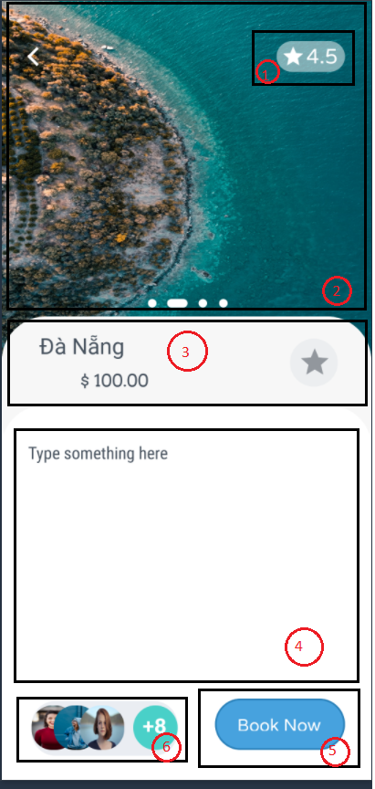

|  |  |  |  |  |
| --- | --- | --- | --- | --- |
| **ID** | **Condition** | **Control Type** | **Target** | **Notes** |
| 1 | Nothing | Text | Rate of tour |  |
| 2 | Scroll | Picture | Picture list of tour |  |
| 3 | Nothing | Text | Tour basic information include tour name, tour price and button to review tour |  |
| 4 | Scroll | Text | Tour detail information |  |
| 5 | Click | Button | Book a tour |  |
| 6 | Nothing | List | List of customers who have used the tour |  |

### UI-03: Shopping cart

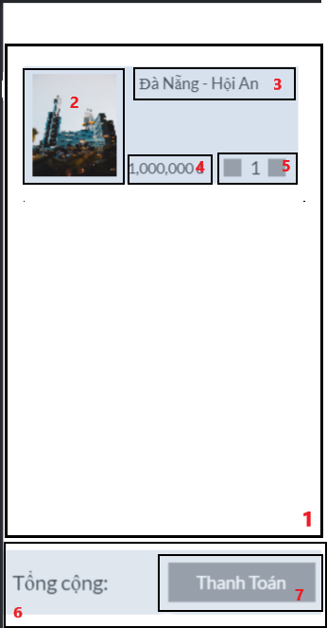

|  |  |  |  |  |
| --- | --- | --- | --- | --- |
| **ID** | **Condition** | **Control Type** | **Target** | **Notes** |
| 1 | Scroll | List | List of booked tours |  |
| 2 | Noting | Picture | Picture of tour |  |
| 3 | Nothing | Text | Name of tour |  |
| 4 | Noting | Text | Price of tour |  |
| 5 | Click | Button | Change the number of tickets you want to book |  |
| 6 | Nothing | Text | The total amount payable for the trip selected for payment |  |
| 7 | Click | Button | Pay for selected tours |  |

### UI-04: Chatbot – text

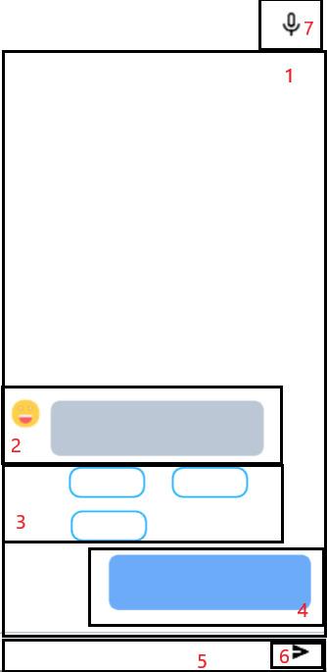

|  |  |  |  |  |
| --- | --- | --- | --- | --- |
| **ID** | **Condition** | **Control Type** | **Target** | **Notes** |
| 1 | Scroll | List | Chat display, scrollable to review old chats |  |
| 2 | Noting | Text | The answer is given by chatbot |  |
| 3 | Nothing | Text | The suggestion is given by chatbot |  |
| 4 | Noting | Text | The question is given by tourist |  |
| 5 | Click | Text box | Enter the question the tourist want to ask |  |
| 6 | Click | Button | Submit the question of tourist |  |
| 7 | Click | Button | Switch to chat with voice chatbot |  |

### UI-05: Chatbot – voice

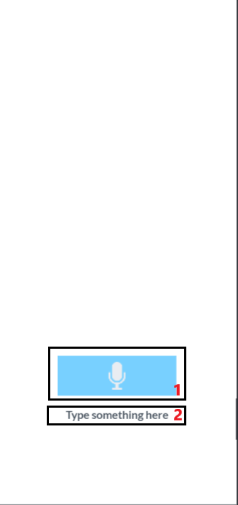

|  |  |  |  |  |
| --- | --- | --- | --- | --- |
| **ID** | **Condition** | **Control Type** | **Target** | **Notes** |
| 1 | Press and hold | Button | Press and hold to start speaking |  |
| 2 | Noting | Text | Show what tourist have said as text |  |

### UI-06: Notification

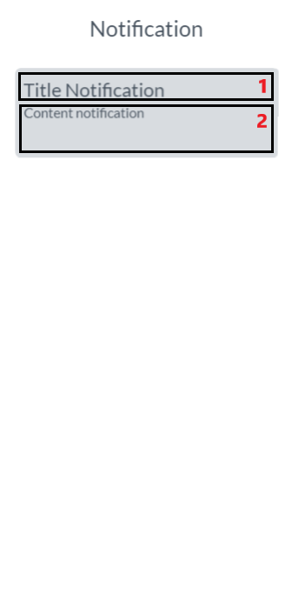

|  |  |  |  |  |
| --- | --- | --- | --- | --- |
| **ID** | **Condition** | **Control Type** | **Target** | **Notes** |
| 1 | Click | Text | Title notification |  |
| 2 | Noting | Text | Centent notification |  |

### UI-07: Profile

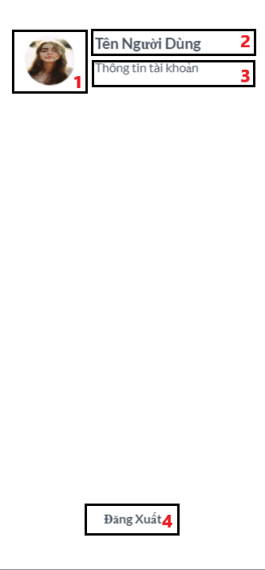

|  |  |  |  |  |
| --- | --- | --- | --- | --- |
| **ID** | **Condition** | **Control Type** | **Target** | **Notes** |
| 1 | Nothing | Picture | Avatar of tourist |  |
| 2 | Nothing | Text | Name of tourist |  |
| 3 | Click | Text | When clicking switch to the detailed profile page |  |
| 4 | Click | Button | Clicking on the tourist will log out of the account |  |

### UI-08: Profile

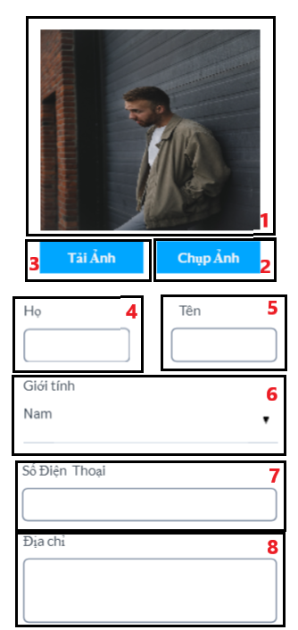

|  |  |  |  |  |
| --- | --- | --- | --- | --- |
| **ID** | **Condition** | **Control Type** | **Target** | **Notes** |
| 1 | Nothing | Picture | Show recently uploaded avatar or current avatar |  |
| 2 | Click | Button | Use your phone's camera to capture and upload avatars |  |
| 3 | Click | Button | Use stock photo as avatar |  |
| 4 | Click | Text box | Enter the tourist first name |  |
| 5 | Click | Text box | Enter the tourist last name |  |
| 6 | Click | Combo box | Choose the tourist gender |  |
| 7 | Click | Text box | Enter the tourist number phone |  |
| 8 | Click | Text box | Enter the tourist address |  |

### UI-09: Login

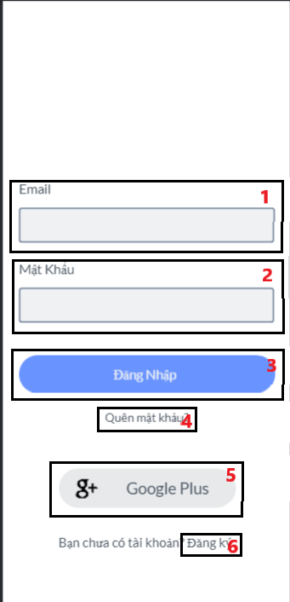

|  |  |  |  |  |
| --- | --- | --- | --- | --- |
| **ID** | **Condition** | **Control Type** | **Target** | **Notes** |
| 1 | Click | Text box | Enter the registered email |  |
| 2 | Click | Text box | Enter the registered password |  |
| 3 | Click | Button | Login on the system |  |
| 4 | Click | Text | Reset their password when a tourist forgets it |  |
| 5 | Click | Button | Sign in with the tourist google account |  |
| 6 | Click | Text | Sign up a new account |  |

### UI-10: Sign up

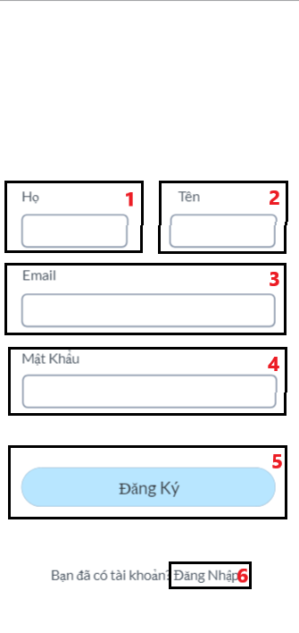

|  |  |  |  |
| --- | --- | --- | --- |
| **ID** | **Condition** | **Control Type** | **Target** |
| 1 | Click | Text box | Enter the tourist first name |
| 2 | Click | Text box | Enter the tourist last name |
| 3 | Click | Text box | Enter the tourist email |
| 4 | Click | Text box | Enter the tourist password |
| 5 | Click | Button | Sign up a new account |
| 6 | Click | Text | Login if you already have an account |

### 2.1.11 UI-11: Short Video

### 

|  |  |  |  |
| --- | --- | --- | --- |
| **ID** | **Condition** | **Control Type** | **Target** |
| 1 | Click | Picture | The user's profile picture, when clicked it will switch to the user's profile |
| 2 | View | Video | Video posted by users |
| 3 | Click | Icon | Click to continue playing the video |
| 4 | Click | Icon | Like video |
| 5 | Click | Icon | Dislike video |
| 6 | Click | Icon | Comment video |

* + 1. **UI-12 Wallet**

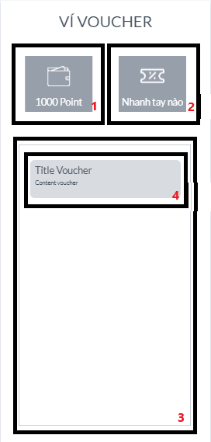

|  |  |  |  |
| --- | --- | --- | --- |
| **ID** | **Condition** | **Control Type** | **Target** |
| 1 | View | Pattern | Displays the user's point received |
| 2 | Click | Pattern | Redeem voucher |
| 3 | Scroll | Scroll View | List Voucher |
| 4 | View | Pattern | Information voucher include: title voucher and content voucher |

* + 1. **UI-13 Voucher**

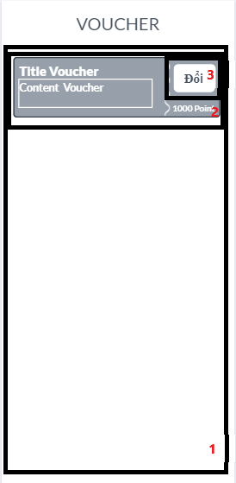

|  |  |  |  |
| --- | --- | --- | --- |
| **ID** | **Condition** | **Control Type** | **Target** |
| 1 | Scroll | Scroll View | List new voucher |
| 2 | View | Pattern | Information of new voucher |
| 3 | Click | Button | Redeem voucher |

* + 1. **UI-14 Map**

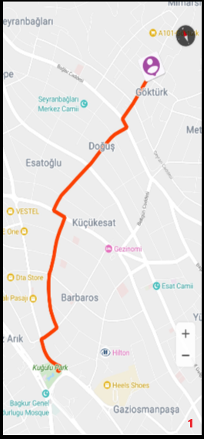

|  |  |  |  |
| --- | --- | --- | --- |
| **ID** | **Condition** | **Control Type** | **Target** |
| 1 | View | Map | Direct tourist to tourist attraction |

* 1. **Web Home**

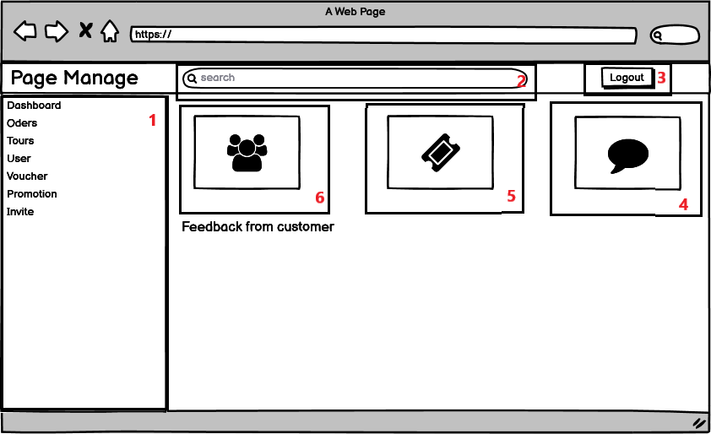

|  |  |  |  |
| --- | --- | --- | --- |
| **ID** | **Condition** | **Control Type** | **Target** |
| 1 | Click | List | Tab navigation |
| 2 | Click | Text box | Search information for tour |
| 3 | Click | Button | Logout of the system |
| 4 | Click | Something | To see all comments on the tours |
| 5 | Click | Something | To see all tiket sold |
| 6 | Click | Something | To see all users |

## UI-Admin

* + 1. **View User**

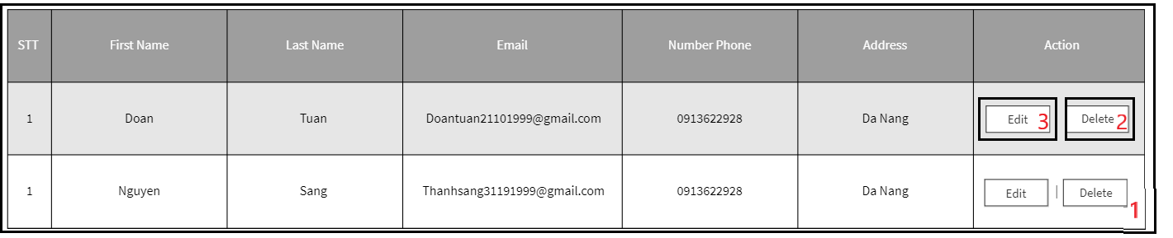

|  |  |  |  |
| --- | --- | --- | --- |
| **ID** | **Condition** | **Control Type** | **Target** |
| 1 | Click | Table | Show basic information of users |
| 2 | Click | Button | Delete user |
| 3 | Click | Button | Edit information of user |

* + 1. **Invite user**

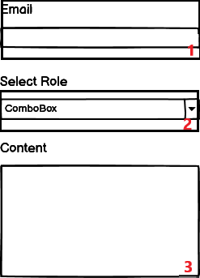

|  |  |  |  |
| --- | --- | --- | --- |
| **ID** | **Condition** | **Control Type** | **Target** |
| 1 | Click | Text box | Enter email |
| 2 | Click | Combo box | Choose role for user |
| 3 | Click | Text area | Enter the content of the letter |

* 1. **UI-Staff**
     1. **View Promotion**

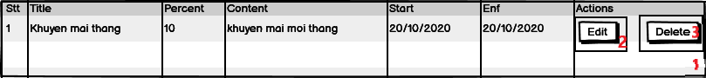

|  |  |  |  |
| --- | --- | --- | --- |
| **ID** | **Condition** | **Control Type** | **Target** |
| 1 | Click | Table | Show basic information of promotion |
| 2 | Click | Button | Delete promotion |
| 3 | Click | Button | Edit information of promotion |

* + 1. **View Voucher**

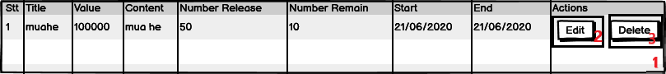

|  |  |  |  |
| --- | --- | --- | --- |
| **ID** | **Condition** | **Control Type** | **Target** |
| 1 | Click | Table | Show basic information of voucher |
| 2 | Click | Button | Delete voucher |
| 3 | Click | Button | Edit information of voucher |

* + 1. **Create Promotion**

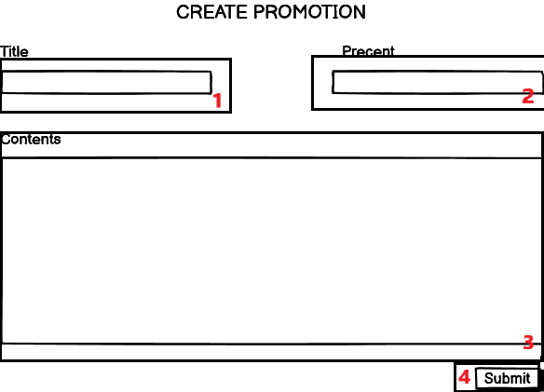

|  |  |  |  |
| --- | --- | --- | --- |
| **ID** | **Condition** | **Control Type** | **Target** |
| 1 | Click | Text box | Enter title of promotion |
| 2 | Click | Text box | Enter percent discount |
| 3 | Click | Text area | Edit content of promotion |
| 4 | Click | Button | Add promotion |

* + 1. **Create voucher**

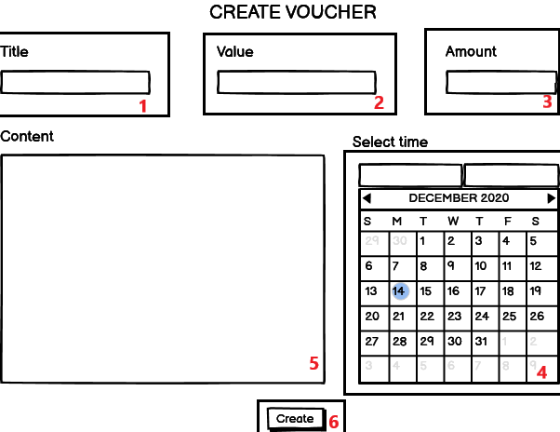

|  |  |  |  |
| --- | --- | --- | --- |
| **ID** | **Condition** | **Control Type** | **Target** |
| 1 | Click | Text box | Enter title of promotion |
| 2 | Click | Text box | Enter value discount |
| 3 | Click | Text box | Edit amount of voucher |
| 4 | Click | calendar | Select start date and end date |
| 5 | Click | Text area | Edit content of voucher |
| 6 | Click | Button | Add voucher |

* + 1. **View Tour**

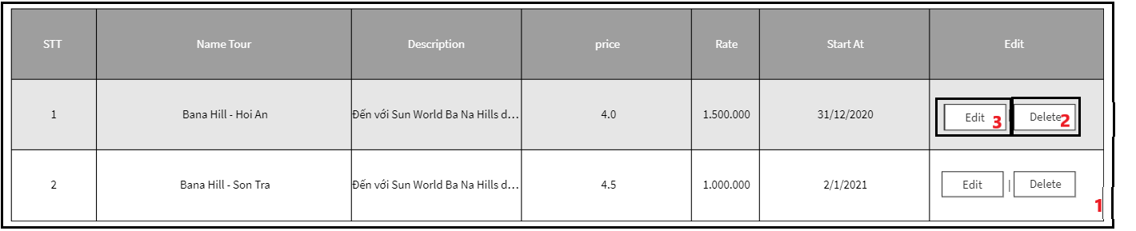

|  |  |  |  |
| --- | --- | --- | --- |
| **ID** | **Condition** | **Control Type** | **Target** |
| 1 | Click | Table | Show basic information of tour |
| 2 | Click | Button | Delete tour |
| 3 | Click | Button | Edit information of tour |

* 1. **Manager**
     1. **View report**

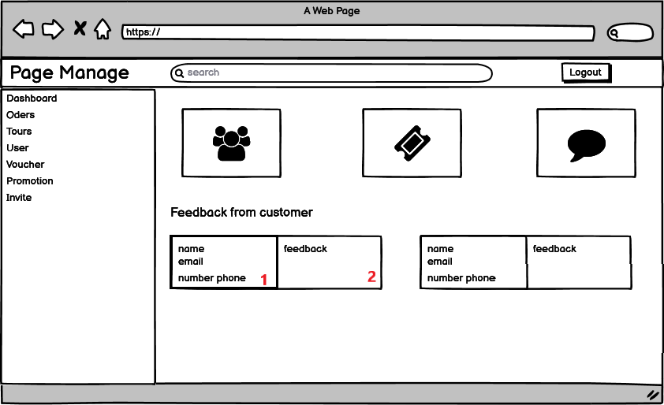

|  |  |  |  |
| --- | --- | --- | --- |
| **ID** | **Condition** | **Control Type** | **Target** |
| 1 | Click | Text | Show basic data of tourist |
| 2 | Click | Text | Show the feedback of tourisr |